**NVivo practical**

Student’s Name

Professor’s Name

University Affiliation

Course Number and Name

Date of Submission

**NVivo practical**

**Section 1: Qualitative Data Analysis**

***Q1:Attitudes to Climate Reparations***

***A)****Hierarchy chart*

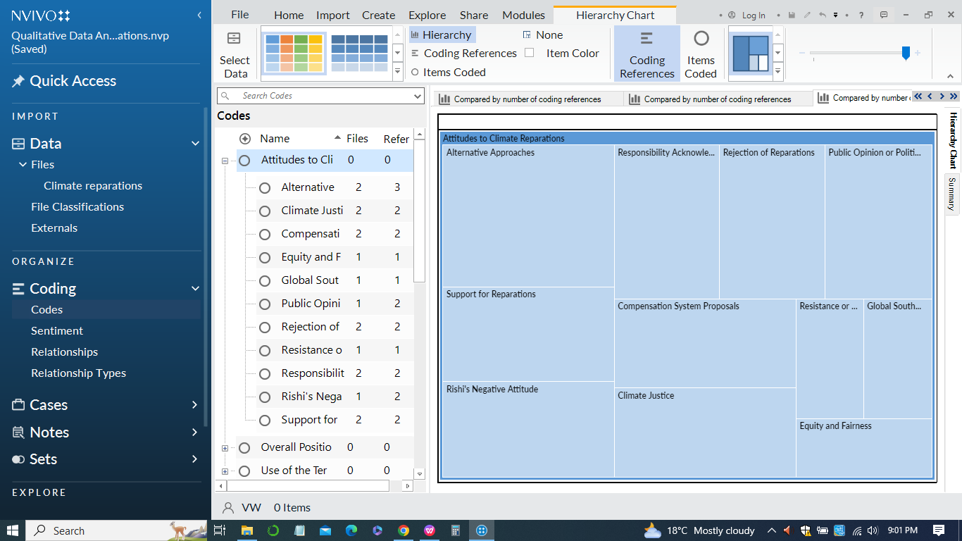

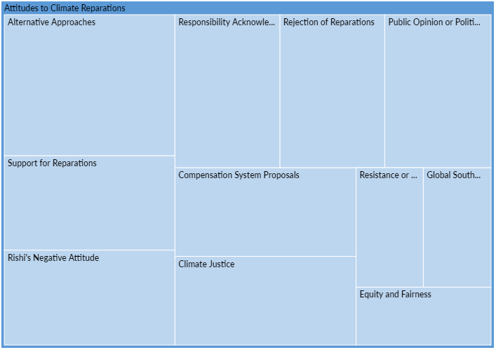

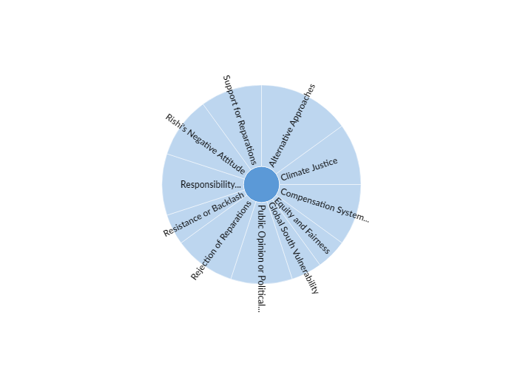

1. *Article A - Daily Mail:*

The attitude towards climate reparations in this article is largely negative. Rishi Sunak, the UK's Prime Minister, insists that paying trillions of pounds in climate change reparations to the worst-hit nations is "not the right approach." He emphasizes that talks over "loss and damage" are distinct from reparations and suggests using UK cash to help developing countries transition to a cleaner future without framing it as reparations. The article proposes an alternative approach by focusing on supporting developing countries' transition without explicitly labeling it as reparations.

1. *Article B - Euronews*

Article B presents a more positive attitude towards climate reparations. It discusses the growing global calls for reparations, especially from countries in the Global South facing severe impacts of the climate emergency. The article highlights the irrefutable case for reparations, emphasizing the need for accountability from those who have historically contributed the most to climate change. Alternative approaches are mentioned, including distinguishing between reparations and finance.

1. *Article C - The Guardian*

The attitude in Article C is supportive of climate reparations. The article reports on a new study that calculates proposed compensation of $170tn in climate reparations by 2050 from rich industrialized countries with high greenhouse gas emissions to historically low-polluting developing countries. The article discusses an alternative approach based on a compensation system that holds wealthy countries historically responsible for excessive emissions accountable to compensate countries that have contributed the least to global heating.

***Q2: Overall positions of each article on climate reparations***

1. *Comparison diagram*

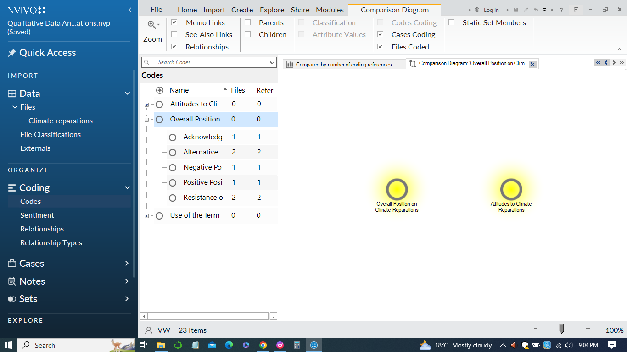

1. *Article A - Daily Mail*

The overall position of Article A on climate reparations is negative. Rishi Sunak, the UK's Prime Minister, rejects the idea of paying trillions in climate reparations, emphasizing that it is "not the right approach." The article portrays a stance against the concept of reparations and frames the discussion around supporting developing countries' transition to a cleaner future without explicitly labeling it as reparations. The emphasis is on fulfilling obligations to help emerging markets without characterizing it as reparations.

1. *Article B - Euronews*

The overall position of Article B on climate reparations is supportive. The article discusses the growing global calls for climate reparations and presents the case that the reparations are irrefutable, especially for countries in the Global South facing severe climate impacts. While acknowledging the resistance to including reparations in discussions, the overall tone supports the idea of reparations as a response to climate injustice.

1. *Article C - The Guardian*

The overall position of Article C on climate reparations is also supportive. The article reports on a new study proposing substantial climate reparations of $170tn by 2050 from wealthy countries responsible for excessive greenhouse gas emissions. The proposed compensation is framed as a matter of climate justice, addressing the unfair burden placed on nations asked to rapidly decarbonize without being responsible for excess emissions. The article suggests that compensating countries that have contributed the least to global heating is a matter of justice in the context of climate breakdown.

***Q3: Context of the word “Colonialism”***

1. *Sunburst diagram*

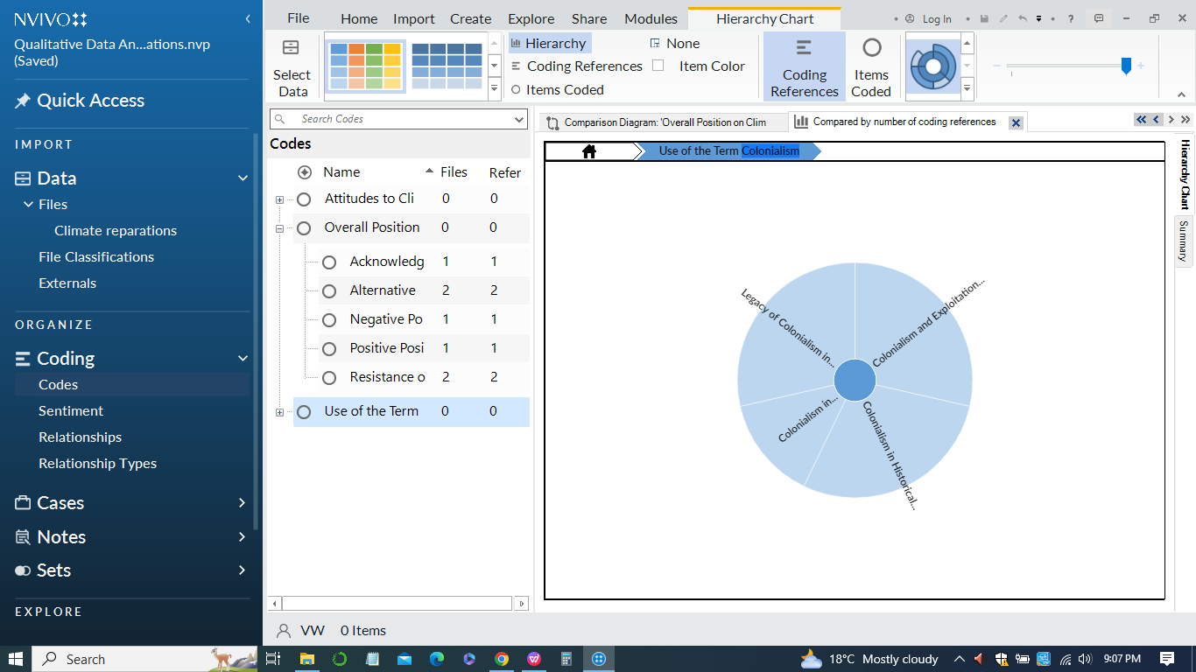

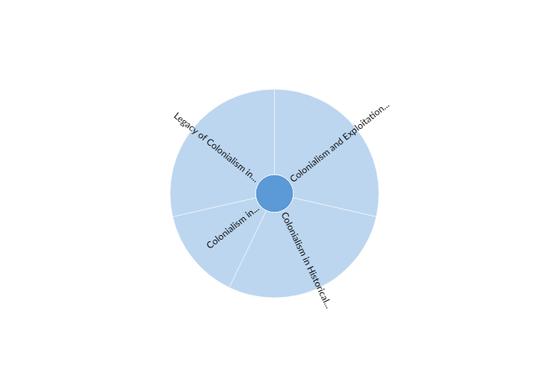

1. *Article A:* Mentions the idea of richer nations acknowledging their role in climate change due to industrialization.
2. *Article B:* Explicitly links the climate emergency to a legacy of colonialism, emphasizing the disproportionate impact on people of color.
3. *Article C:* Describes climate change as a reflection of patterns of atmospheric colonization, attributing excess emissions to wealthy classes.

In sum, the use of the term "colonialism" in the articles reflects a critical perspective that places climate change within the historical context of colonial practices, emphasizing the need for acknowledgment, responsibility, and reparative actions in contemporary climate discussions.

**References**

Jack, Tulia. 2020. Qualitative Coding and Analysis using NVivo PC/MAC Workbook. Lund University. Download from Canvas 6.

Bazeley, Patricia. 2013. Qualitative Data Analysis: Practical Strategies. London: SAGE. (Chapter 6 “Naming, organising, and refining codes”) Available as a hardcopy at the library 13.

Boyatzis, Richard E. 1998. Transforming Qualitative Information: Tematic Analysis and Code Development. SAGE. 14.

Charmaz, Kathy. 2006. Constructing Grounded Teory: A Practical Guide through Qualitative Analysis. SAGE Publications. Available as an e-book on the library website 15.

Fereday, Jennifer & Eimear Muir-Cochrane. 2006. “Demonstrating Rigor Using Tematic Analysis: A Hybrid Approach of Inductive and Deductive Coding and Teme Development”, International Journal of Qualitative Methods 5(1): 80-92. 16.

Glaser, Barney G., and Anselm L. Strauss. 1967. Te Discovery of Grounded Teory: Strategies for Qualitative Research. Chicago: Aldine Pub. Co. 17.

Strauss, Anselm L. 1987. Qualitative Analysis for Social Scientists. Cambridge: Cambridge University Press. 18.

Saldana, Johnny. 2015. Te Coding Manual for Qualitative Researchers. 3rd edition. Los Angeles; London: SAGE Publications Ltd. (Chapter 3 “First cycle coding methods”) Available as a hardcopy at the library

Bazeley, Patricia. 2013. Qualitative Data Analysis: Practical Strategies. London: SAGE (chapters 11-13; pp. 327-421). Available as a hardcopy at the library 3.

Braun, V. & Clarke, V. 2012. “Tematic analysis”. In H. Cooper, P. M. Camic, D. L. Long, A. T. Panter, D. Rindskopf, & K. J. Sher (Eds), APA handbook of research methods in psychology, Vol. 2: Research designs: Quantitative, qualitative, neuropsychological, and biological (pp. 57-71). Washington, DC: American Psychological Association. Download here 4.

Bryman, Alan. 2012. “Chapter 13: Content Analysis.” Pp. 288–308 in Social Research Methods, 4th Edition. Oxford; New York: Oxford University Press. Available as a hardcopy at the library 5.

King, Gary, Robert O. Keohane, and Sidney Verba. 1994. “CHAPTER 1: Te Science in Social Science.” Pp. 3–33 in Designing Social Inquiry. Princeton University Press. Available as an e-book on the library website 7.

Lofland, John and Lyn H. Lofland. 1995. “Chapter 9: Developing Analysis.” Pp. 181–203 in Analyzing Social Settings: A Guide to Qualitative Observation and Analysis. Wadsworth. Available as a pdf online or as a hardcopy at the library

**Appendix Excerpts for NVivo Coding Analysis**

1. ***Hierachy charts***



1. ***Comparison charts***



1. ***Sunburst***

